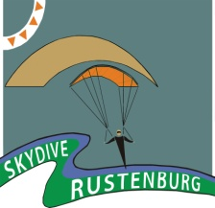
RANCH BOOGIE
Friday 5th – Tuesday 9th August 2011

Registration Form
Once completed please e-mail with proof of payment to: skydive.rustenburg@gmail.co.za

1. Personal Information
Name:
Surname:
ID / passport number:
Cell phone:
Email address:
Medical aid:
Medical aid no.:
Next of Kin (Name and Surname):
Next of Kin contact no:
2. Skydiving Information
Current DZ:
PASA #:
Military / Police #:
License and Ratings:
Main canopy make and size:
Reserve make & size:
Reserve repack date:
No. of jumps:
No. of years skydiving:
No. of jumps in last 3 months:
3. Planned Activities (approximate)
August | Fri  5th | Sat  6th | Sun 7th | Mon 8th | Tues 9th
Expected arrival date / time
Expected departure date/ time

 | Atmo | CF | FS | FreeFly | Wingsuit
How many jumps?
Interested in big ways?
Coaching required?

Type of display / presentation you would like to see:

4. Participation in Symposium – Request.
Display / Exhibit / Talk / Presentation

Type of display:
Subject of talk and duration:
Display area required:
Department / company:
Contact Person:
Cell Nr:
Email address:
Equipment requirements:

.

5. Registration
- The event is open to all PASA Members and Visiting International Skydivers.
- Temporary International PASA Membership Cards will be available for members of foreign Parachute Associations affiliated to the FAI. PASA International Cards are valid at all PASA Drop Zones for 3 months.
- For the 2011/12 membership year, PASA members serving in the armed forces will pay 50% of the Aero Club fees (R135). The PASA fee for these military members who do not hold a PASA rating is R100 (inclusive of sport membership). Those who do hold PASA ratings, pay the full PASA fee (R410).
- Please ensure your PASA paperwork and payments are up to date prior to the event. www.Para.co.za

Registration for PASA Members | R 350
Registration for PASA Members with Military or Police Nr. | R 175
Day registration: | R 200
Slot rate (12 000ft AGL): | R 250

6. Accommodation
• Kolbe Tented Camp - R150 or R100 (own bedding) Per person per night
A combination 4-sleeper and 6-sleeper tents. Max 76 Persons. Self catering facilities are provided. Email: karen.z.fourie@za.pwc.com
• 5-Star 6 Sleeper Self Catering Golf Chalets - R1800 per chalet per night
Overlooking the Golf Course. Max 6 persons (2 on sleeper couch in lounge). Email: reservations@theranch.co.za
• Protea Hotel Ranch Resort - R 800 per room per night
7 Suites and 103 Deluxe 4-Star Hotel Rooms. Email: reservations@theranch.co.za
• Camping (own equipment)- Included in registration fee
In the designated area alongside the permanent Tented Camp. Email: karen.z.fourie@za.pwc.com

Please use: “The Ranch SkyDiving Boogie” as reference when making bookings via reservations@theranch.co.za

7. Payments: Banking details
- Please make advance payments for Registration and Jump Tickets.
- Tickets will be issued at the event on registration.
- During the event cash or internet transfers are possible.
- Nearest cash machine: The Ranch Petrol Station on the N1.
- Credit / Debit Card facilities at Protea Hotel Ranch Resort may be used at the event by special arrangement – charges between 5% and 7% will apply.
- Proof of Payment should accompany your registration form in the same email. Bring your own printed copy of this form as well as proof of payment with you to ensure smooth and efficient proceedings on arrival.

Wireless Internet is available at Protea Hotel Ranch Resort in most areas.

Make payment to:
ABSA
Rustenburg Skydiving Club
Savings Acc 9240815078
Waterfall Mall 632005
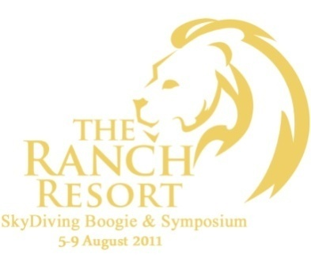

REFERENCE: Ranch + YOUR NAME

